 | Nomination Form | 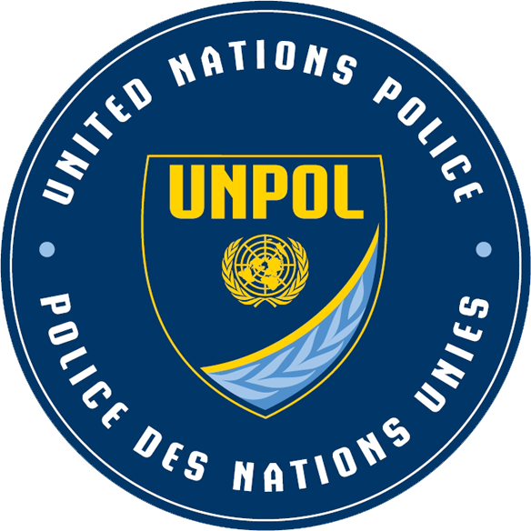

Please PRINT all necessary information. An electronic copy of the form can be obtained by contacting the persons listed on the last page.
Nomination for: Regional course for the Female Senior Police Officer Command Development Course, Belem, State of Para, Brazil, 10-16 July 2018
DEADLINE: 15 APRIL 2018
Family name/Surname (as it appears in passport)
First name (as it appears in passport)
Address
Phone number, starting with country code
Fax number, starting with country code
Cellular phone number, starting with country code
E-mail
City and country of birth
Date of birth (day/month/year) |  | Male Female
Emergency contact
Citizenship
(passport-issuing country)
Place of issuance of passport
Passport number |  | Valid until:
Place of departure to course venue (international airport)
Place to return from course venue (international airport)
Request for funding support | YES NO
Date of entry into police | Day Month Year
Number of years of police experience
Number of years of police command/management experience
Food allergies

Police Rank
Military Rank equivalent
Job Title
Brief professional history: Describe main duties and responsibilities (maximum of 300 words).  Please attach your:  1. Personal History Profile (PHP) / P11  2. Employment and Academic Certification  Please confirm your commitment to be deployed to a United Nations peacekeeping operation (minimum one year) if selected. | Academic qualification (degree, awarding institution, year):  Date of entry in police (day/month/year):  Job experience (post, area, duties, duration):  Miscellaneous (awards/honours, fluency in English or French):  YES, I confirm commitment to deploy to a United Nations peace operation if selected.

Applications are to be authorised by the applicant’s authorities:

- Certifying that the nominated female police command officer fulfils the following criteria:

- The commitment to be nominated by their respective country for a command position in a United Nations peace operation
- The commitment for the person to deploy to a United Nations peace operation if selected
- Minimum rank of Lieutenant Colonel or equivalent
- Minimum of seven (7) years police experience
- Previous command experience
- Minimum of a Bachelor’s degree
- Easily read, speak, understand and write in English
- Graduation from a certified police academy or similar law enforcement training institution

Name:
Reasons for authorizing the applicant (short paragraph of not more than 250 words to be written by the supervisor).  Please confirm that the commitment that the country is committed to nominating the candidate for a command position in a United Nations peacekeeping operation. | Yes, I confirm the commitment that the country is committed to nominating the candidate for a command position in a United Nations peacekeeping operation.
Signature:

Clarification of signature, incl. rank/title
Address:

Phone number: |  | Fax number:
E-mail:
Date:

Checklist for the nomination package:
□ Nomination form
□ Personal History Profile (PHP)
□ Employment and Academic Accreditation
□ HR Mini Master Registration Form
□ Copy of passport
□ Passport photo

Please note that incomplete documents will not be accepted.

Please send this nomination form by e-mail by 15 April 2018 to:

Ms. Lea Angela Biason, Gender Affairs Officer
Strategic Policy and Development Section, Police Division, OROLSI, DPKO, United Nations
One United Nations Plaza
New York, NY, 10017 USA
Tel: +1-212-963-0738
E mail: biason@un.org

With copy to:

Ms. Fayola Ayo Atkins, Team Assistant
United Nations
Police Division, OROLSI
Department of Peacekeeping Operations
United Nations, New York, NY 10017
Tel: +1.212-963-6810
E-mail: atkinsf@un.org

Ms. Mehrin Sharif, Team Assistant
Strategic Policy and Development Section, Police Division, OROLSI, DPKO, United Nations
One United Nations Plaza, DC1-0538
New York, NY, 10017 USA
Tel: +1-212- 963-s4138
E mail: sharif9@un.org

